**Conclusions**

With strong communication and hard work between all members of the team, a fully working prototype was created. Here, we detail the costs registered during the process, the sustainability of the device as well as its ethical consequences and future improvements that could be made for a better working solution.

# **Costs**

**Material Costs**

The budget given by Imperial College London was £500, and the material budget spent by the group was £257.44. Most of the costs were spent on the processing board and camera module of our product, while some money was used on driving objects for demonstration purposes. The manufacturing cost for one DARE device is 34,07 + 19,79 + 25,79 + 7 = £86,65.

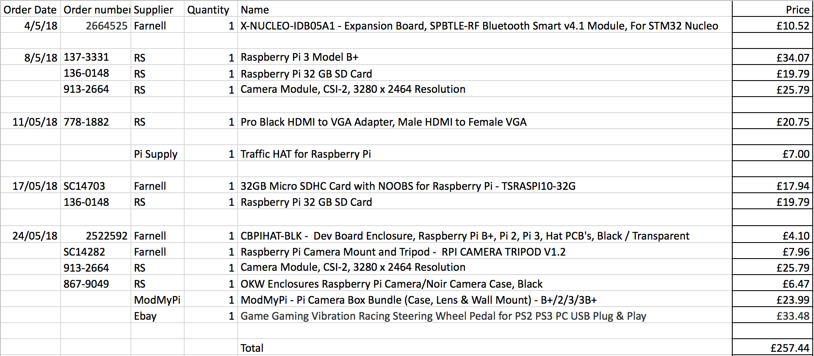

Figure 1: Budget details

## **Travel Costs**

The travel costs are comprised of the railway tickets that our team bought to visit the ARM company in Cambridge on 15th June 2018.

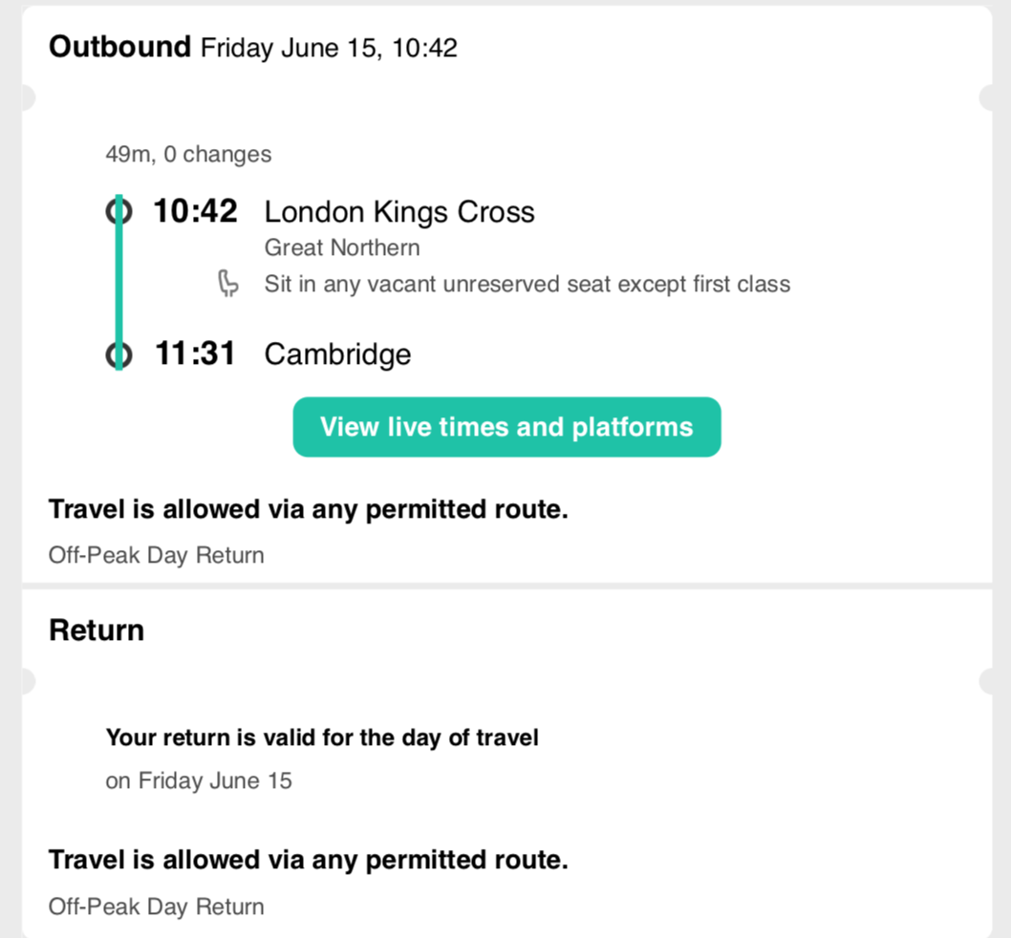



Figure 2: Ticket train to Cambridge

## **Total Costs**

The entire budget involved was thus comprised of material costs and travel costs, which accounts for a total of £257.44 + £153.90 = £411.34

1. **Ethical report**

The testing and utilisation of our device touch upon various ethical concerns, which we are committed to tackle in order to protect users of the device.

Testing

Drowsy drivers are a danger to other road users. Hence, for evident ethical reasons, we could not conduct experiments on the road in order to test our device. As a result, we have used the driving simulator located on the 10th floor of the EEE building for testing.

Users’ privacy and confidentiality

One of the most significant ethical concerns, and also a legal issue, is the protection of individuals’ privacy. Indeed, individuals have a right to choose which information they disclose to companies and which information they keep for themselves. This implies that ARM should not film users for their own purposes without users’ consent. It follows that ARM should neither store nor transfer any data regarding its users if these have not agreed to. As a result, we recommend that ARM should update its privacy policy to meet the high standards of the new European data protection law, known as the General Data Protection Regulation (GDPR) if it hasn’t already done so. This new legislation will significantly strengthen customers’ privacy rights by governing how data is processed, stored, utilised and managed by companies.

Employees’ privacy and confidentiality

Technology enables companies to have a greater overview of their employees’ practices. For instance, some companies include clauses in employment contracts that grant them the authority to monitor the electronic activity of their staff. By doing this, some ethical violations become readily apparent, such as the infringement upon employees’ right to privacy. We believe that ARM should handle its employees’ privacy with the same ethical standards as its customers’ privacy, and therefore should not use our device to monitor and record customer data.

Other issues

Our device detects drowsiness by checking lighting pattern zones on the user’s face. Yet, this could potentially be an issue for users with a dark skin colour. Indeed, the device might not work as efficiently with these users as it would with users of lighter skin colour, thus creating discrimination between users and raising ethical concerns.

1. **Sustainability**

The world is now facing significant environmental challenges, due to the increasing levels of waste and pollution. According to the UN Environment Assembly, 8.3 billion tons of plastic have been produced while only 9% of the plastic waste is recycled1. Consequently, we believe that ARM should be committed to designing products with a low environmental impact.

To achieve this, we added the SPI resin identification code “seven” on the 3D-printed case to help recyclers identify the material accurately and efficiently (see Figure 3 below). PLA can be recycled to monomer by thermal depolymerisation or hydrolysis. The monomer can be used to produce the raw PLA material stock without changing its original properties. Only four screws are used to assemble the case, simplifying the disassembly process and reducing the materials waste, which also aids the recycling process.

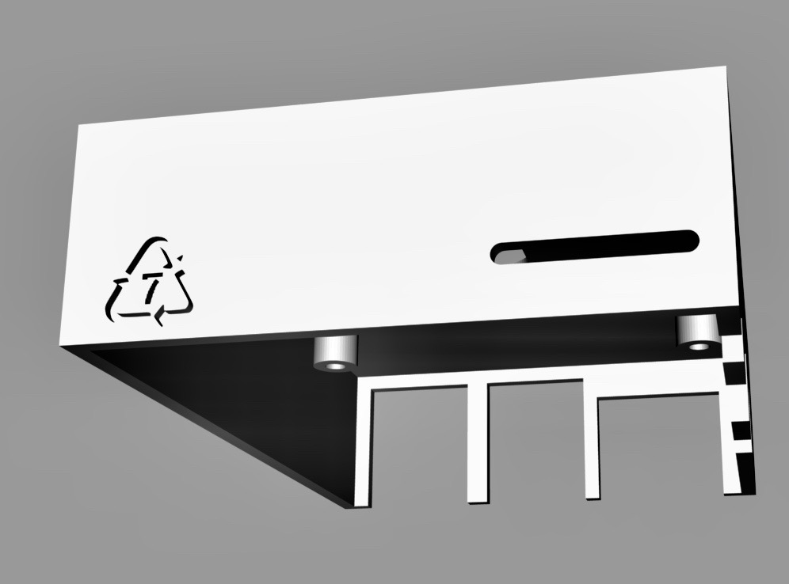

Figure 3: Case with identification code

For future mass production, we would like to apply the ISO 14001 standard, which is an internationally recognised framework for setting up an environmental management system to improve resource efficiency, reduce waste and cut waste management costs. For instance, following such framework would minimise environmental impact across the product lifecycle and enhance the performance of the supply chain, as well as qualify, monitor and control the ongoing environmental impact of the manufacturing operation.

# **Future Work**

The current prototype presents some limitations: the face detection algorithm is more targeted at European users without glasses or hat, the list of songs available is limited, and the 3D-printed case cannot stay fixed on the dashboard, which was temporarily solved by using blue tack to stick it. Therefore, if the project was to be taken from where we left it and improved, we recommend that the following specific points should be considered.

* Monitor more drowsiness-related measures to better estimate the driver’s state, such as steering wheel movement, lane position, or heart rate.
* Build a pedestal that can fit any dashboard to mount the device on.
* Increase the number of songs available, by creating an interface with Spotify for example.
* Increase the computing power. Multiple options would be available: use a board that is targeted for IoT vision application (such as the ARM dragonboard, which was provided to us only one week before the demonstration, but should be publicly available in early 2019), or use a lighter operating system (such as Raspbian Lite).
* Improve the face recognition algorithm. If computer power was increased, numerous methods could be implemented to improve the face detection. Reinforcement learning would mean the device permanently learns how to correctly identify a face and would therefore adapt to its user, or just using a stronger and heavier face detector that uses more advanced machine learning techniques. This could also reduce discrimination issues with regards to users of darker skin colour.

Overall, this project was extremely gratifying and challenging, and offered a great opportunity for all team members to apply the knowledge learnt at Imperial College London to real-life engineering problems. A correct splitting of working tasks, combined with a good communication, enabled the group to come up with a working solution and gave each and every one of us a good overview of how the engineering industry functions.

References

*[1] Patrick Mwangi. 2017. Marine | UN Environment Assembly. [ONLINE] Available at:* [*http://web.unep.org/environmentassembly/marine*](http://web.unep.org/environmentassembly/marine)*. [Accessed 27 June 2018].*

*[2] The Effects of Technology on Work Ethics | Chron.com. 2018. The Effects of Technology on Work Ethics | Chron.com. [ONLINE] Available at:*[*http://smallbusiness.chron.com/effects-technology-work-ethics-18716.html*](http://smallbusiness.chron.com/effects-technology-work-ethics-18716.html)*. [Accessed 27 June 2018].*